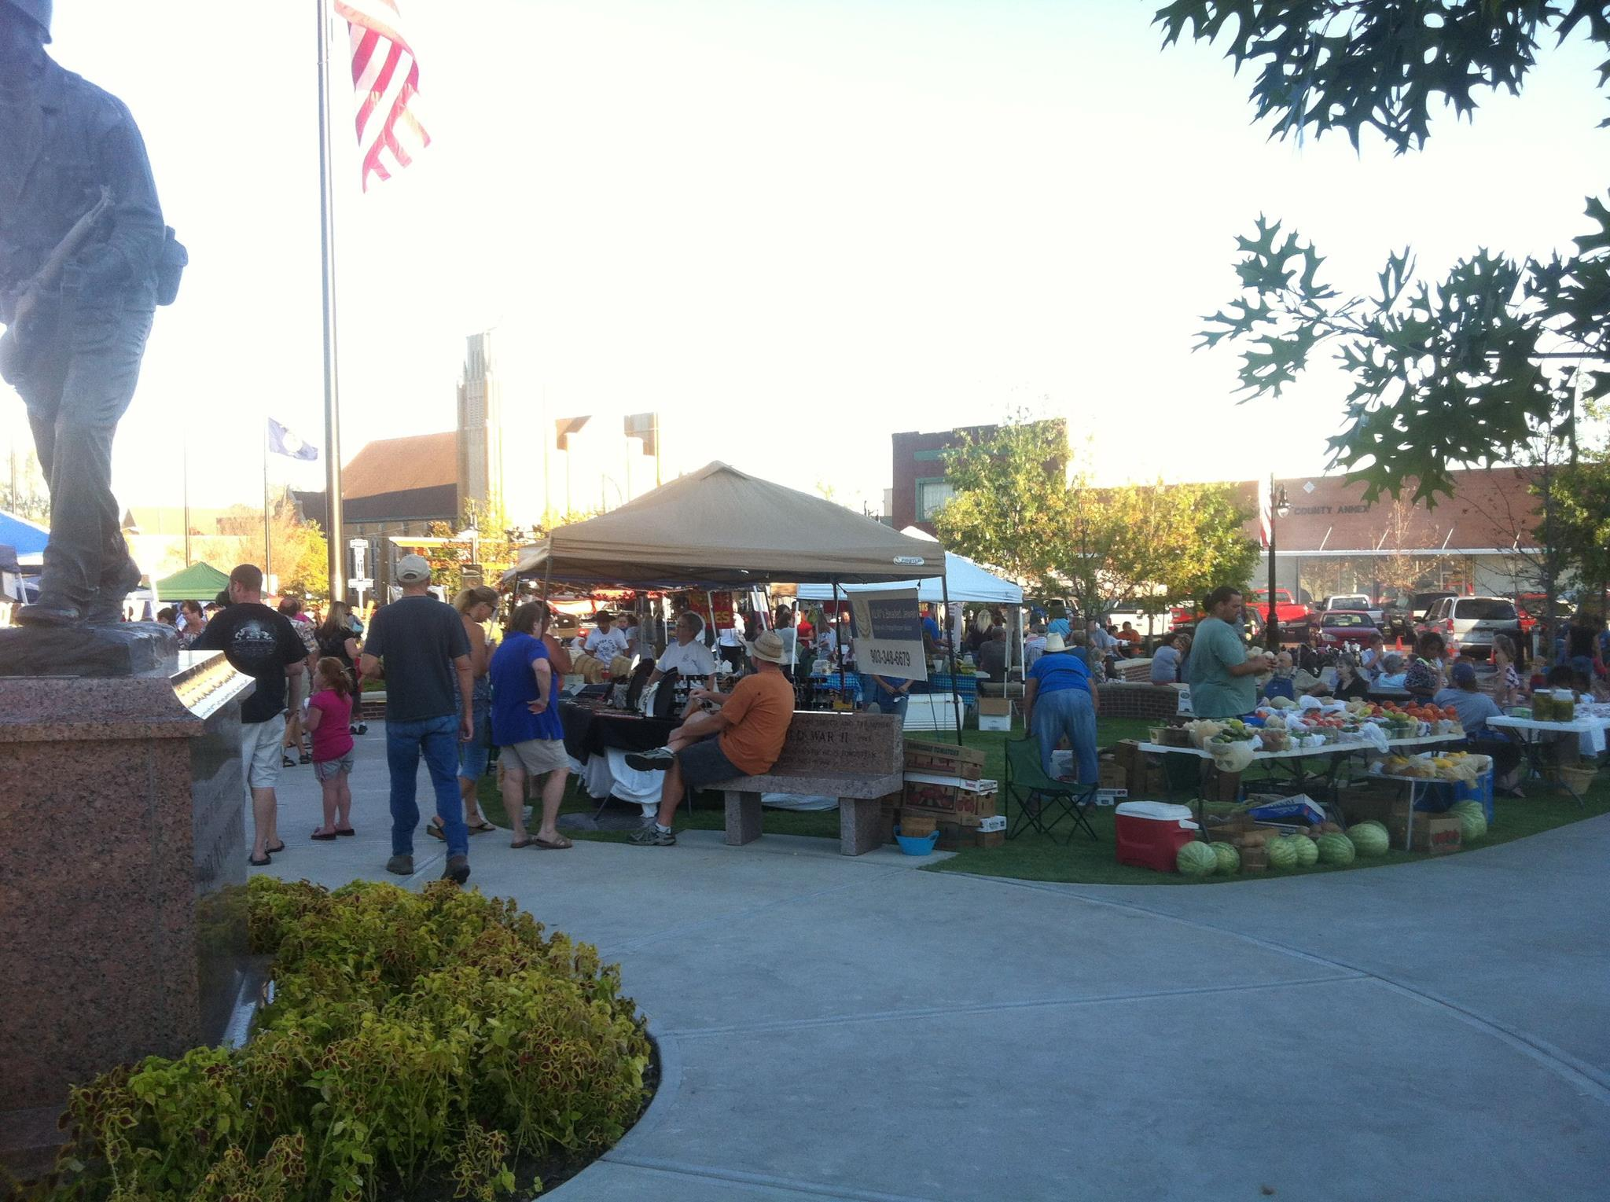  Sponsorship Matters  Market and Movie Night support community, small business, fun and family.  We strive to support local.  We encourage the arts through the Market, giving our talented community a cultivated, public environment to sell, network, perform and grow.  We provide free live music from amazing local musicians.  We foster a fun atmosphere for families to enjoy our downtown, shop and eat local.  Partnering with us guarantees the continuity of our amazing musicians and Friday Night Movies. | Creating Little Bits of Magic  Family Movie Friday  Movie Night is a staple outdoor movie experience for the whole family. Movies run after dark, every Friday, during the summer break.  2023 Titles Include:  To be determined.  City of Sulphur Springs  201 Davis Street N. Sulphur Springs, TX. 75482 | Celebrate Local 2023  Celebration Market  May 20 -Sept. 16  City of Sulphur Springs  - Celebration City Sponsorship Guide
Platinum Partner  $10,000  (1)  _______________________________________________  Top/Side stage banners for 17 Market concerts (provided by sponsor)  Weekly ad on City Social Media (FB, Twitter, Instagram) from May to Sept.  4 light pole banners downtown, displayed from May to Sept.  Weekly graphic banner on e-newsletter from May to Sept.  Graphic banner placed on City website  Sponsor banner displayed at Family Movie Night (11 Fridays)  Booth Space at Celebration Market | Gold Partner  $5,000  (2)  _______________________________________________  Sponsor banner displayed, front stage at 17 Market concerts  Weekly ad on City Social Media (FB, Twitter, Instagram) from May to Sept.  2 light pole banners downtown displayed May-Sept.  Weekly graphic banner on e-newsletter from May to Sept.  Graphic banner placed on City website  Sponsor banner displayed at Family Movie Night (11 Fridays)  Bronze Partner  $500  (6)  _______________________________________________________  Bi-Monthly ad on City Social Media (FB, Twitter, Instagram)  Weekly graphic banner on e-newsletter  Sponsor banner displayed, front stage at 17 Market concerts  - Sponsor banner displayed at Family Movie Night (11 Fridays) | Silver Partner  $1,500  (4)  _______________________________________________  - Weekly ad on City Social Media (FB, Twitter, Instagram) from May to Sept.  - Weekly graphic banner on e- newsletter from May to Sept.  - Sponsor banner displayed at 17 Market Concerts  - Sponsor banner displayed at Family Movie Night (11 Fridays)

