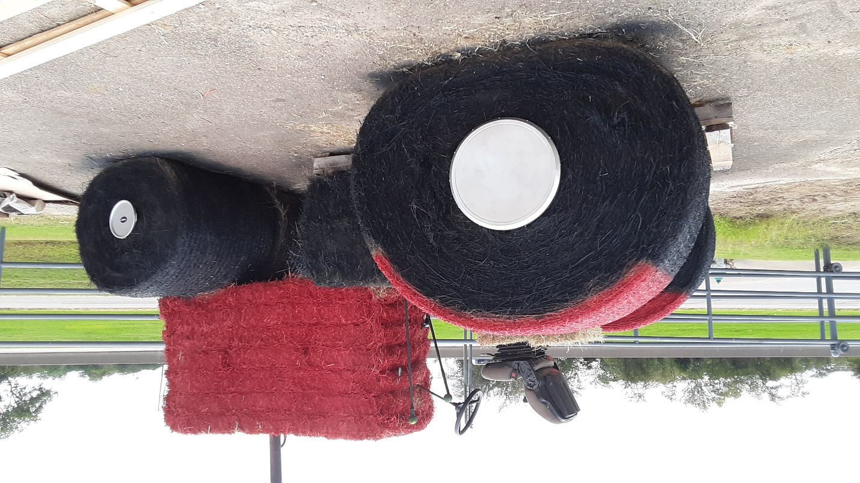
2020 Hopkins County Texas Fall Festival
Hay Bale Sculpture Contest Rules Open to all of Hopkins County

The purpose of this event:
- Creating a Fun and Entertaining way to Celebrate the Hopkins County Fall Festival
- Recognizing the Importance of Hay on the Economy of Hopkins County
- Developing County Spirit, Teamwork, and Hometown Pride
- Encouraging our community to show support to this industry and have fun!

Two Sculpture Categories :
Multiple Bales: More than 1 Round Bale
Single Bales: 1 Round Bale (with/without square bales)

Prize Money for each category
1st -$200.00 2nd - $100.00 3rd - $50.00

Rules and Regulations:
- Entries open to Individuals, Families, Businesses, Schools, Churches, Group Organizations, 4-H Clubs, FFA Chapters, ETC. Open to all of Hopkins County !!!
- NEW !!!! Winning Entries used in previous years can be displayed but will not be in the judging category
- Sculpture must be of good clean, wholesome nature
- Hay bale sculpture can go up earlier but must be completed by Monday, October 12 2020.
- Spray Paint and Latex (water based) may be applied to the hay bale. NO OIL BASE PAINT.
- Bales can be placed lying on their side or standing on end
- You can display a sign for your organization.
- All shapes and sizes of hay may be used to create your hay bale art. You may choose to use round bales, square bales, loose hay or grasses, sticks or wood, cardboard and other materials to create your sculpture
- Entries will be judged on eye appeal, construction stability, use of materials and creativity
- Judging will take place on Friday, October 16th Winners will be announced at the Civic Center on Saturday, at 2:00 October 24th
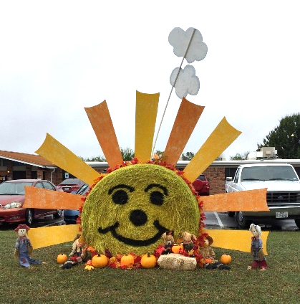
Hopkins County Fall Festival Mail Entry Form
Attach drawing of Bale Sculpture and send to:
Shirley Patchen, 240 Turtle Creek,
Sulphur Springs Texas 75482

Name ____________________________________________________

Person to call ___________________________Phone #____________________

Email Address_____________________________________________________
Entry Form must be received by Tuesday, October 6st or contacted committee
Shirley Patchen 903 885 5914 or Sue Potts 903 485 3241
Pictures of sculptures can and will be used to promote this event.

