2019Hopkins County Texas Fall Festival
Hay Bale Sculpture Contest Rules Open to all of Hopkins County
The purpose of this event:
- Creating a Fun and Entertaining way to Celebrate the Hopkins County Fall Festival
- Recognizing the Importance of Hay on the Economyof Hopkins County
- DevelopingCountySpirit, Teamwork,andHometown Pride
- Encouraging our community to show support to this industry and have fun!

Two Sculpture Categories :
Multiple Bales: More than 1 Round Bale
Single Bales:1 Round Bale (with/without square bales)

Prize Money for each category
1st -$200.00 2nd - $100.00 3rd - $50.00

Rules and Regulations:
- Entries open toIndividuals, Families, Businesses, Schools, Churches, Group Organizations, 4-H Clubs, FFA Chapters, ETC.Open to all of Hopkins County !!!
- Sculpture must be of good clean, wholesome nature
- Hay bale sculpture can go up earlier but must be completed byMonday, October 14 2018.
- Spray Paint may be applied to the hay bale. NO OIL BASE PAINT.
- Bales can be placed lying on their side or standing on end
- You can display a sign for your organization.
- All shapes and sizes of hay may be used to create your hay bale art. You may choose to use round bales, square bales, loose hay or grasses, sticks or wood, cardboard and other materials to create your sculpture
- Entries will be judged on eye appeal, construction, use of materials and creativity
- Judging will take place on Friday, October 18th.Winners will be announced at the Civic Center on Saturday, at 2:00 October 26th

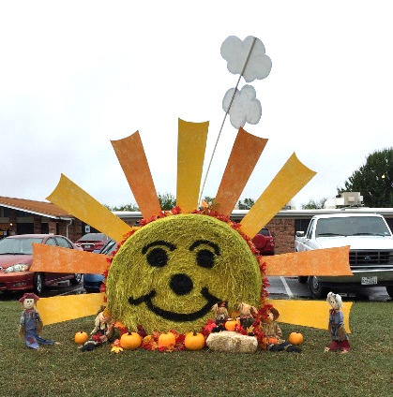
Hopkins County Fall Festival Mail Entry Form
Attach drawing of Bale Sculpture and send to:
Shirley Patchen, 240 Turtle Creek,
Sulphur Springs Texas 75482

Name ____________________________________________________

Person to call ___________________________Phone #____________________

Email Address_____________________________________________________
Entry Form must be received by Tuesday, October 1st or contacted committee
Shirley Patchen 903 885 5914 or Sue Potts 903 485 3241
Pictures of sculptures can and will be used to promote this event.

